- \Operation\Basic settings\Speed
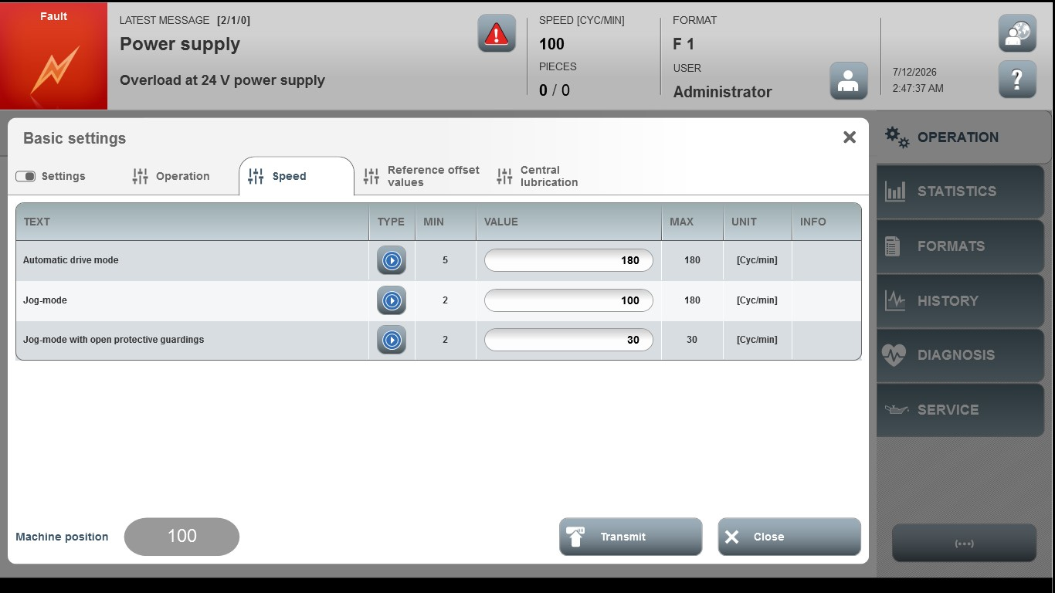
Acceptance criterion | Limits | Pass / Fail: Dev-No. | Date | Initials
Screen matches screenshot | N / A
Automatic drive mode | 5 … 200
Jog-mode | 2 … 180
Jog-mode with protective guardings open | 1 ... 30

